Task on Cloud Front & Route 53

1.Purchase one domain from GoDaddy.

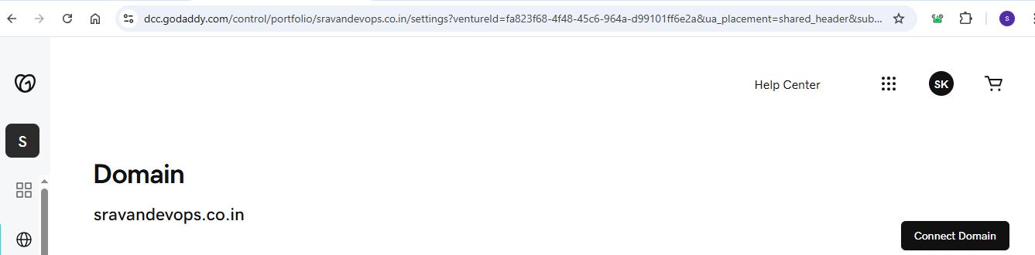

2. Deploy static website in S3.

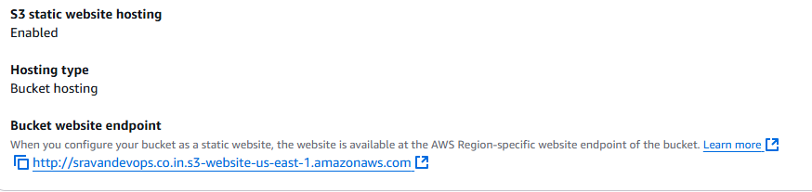

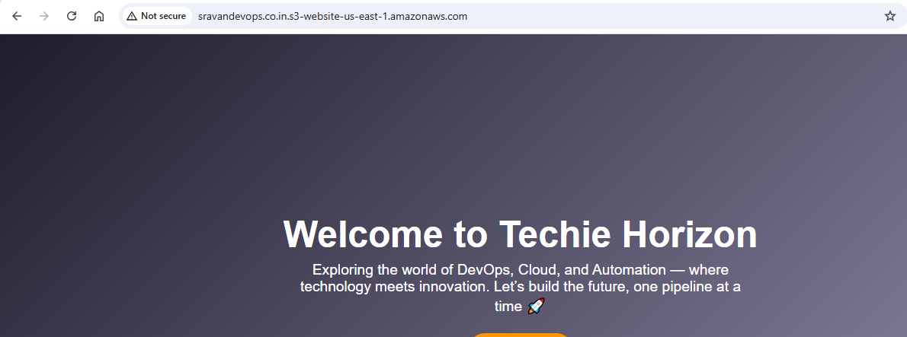

3.Create a CDN and attach one SSL certificate.

**Step 1 — Verify Domain Ownership**

We need AWS Certificate Manager (ACM) to issue an SSL certificate.

1. Go to **AWS Certificate Manager (ACM)** in the **US East (N. Virginia)** region (CloudFront requires ACM certificates in this region).
2. Click **Request certificate → Request a public certificate**.
3. Enter:
4. sravandevops.co.in
5. www.sravandevops.co.in
6. Choose **DNS validation** → ACM will give you a CNAME record.
7. Add this CNAME record in your domain DNS (Route 53 or your registrar’s DNS settings).
8. Wait for ACM to validate ownership (status will change to **Issued**).

**Step 2 — Create CloudFront Distribution**

1. Go to **CloudFront console** → **Create distribution → Web**.
2. Set Origin Domain:
3. sravandevops.co.in.s3.amazonaws.com

(select your S3 bucket or type exact endpoint).

1. Set Viewer Protocol Policy → **Redirect HTTP to HTTPS**.
2. Allowed HTTP Methods → GET, HEAD.
3. Cache Policy → Use **CachingOptimized**.
4. **Alternate Domain Names (CNAMEs)**:
5. sravandevops.co.in
6. www.sravandevops.co.in
7. **SSL Certificate** → choose your ACM certificate for sravandevops.co.in.
8. Click **Create Distribution**.

**Step 3 — Wait for Deployment**

CloudFront deployment takes ~10–15 minutes.

**Step 4 — Configure DNS**

If you use **Route 53**:

1. Go to **Route 53 → Hosted Zones → sravandevops.co.in**.
2. Create an **A record** (Alias) for:
3. Name: sravandevops.co.in
4. Alias to: CloudFront Distribution
5. Repeat for www.sravandevops.co.in if needed.

If you use another DNS provider:

* Create a **CNAME record** pointing to your CloudFront distribution domain name (dxxxxxxxxxxxx.cloudfront.net).

**Step 5 — Test**

Open:

https://sravandevops.co.in

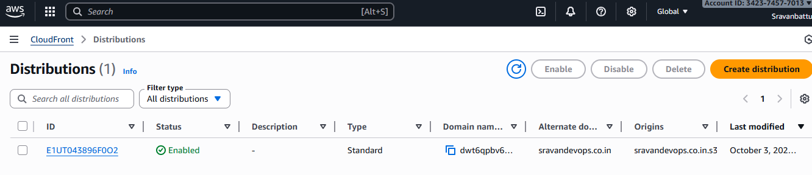

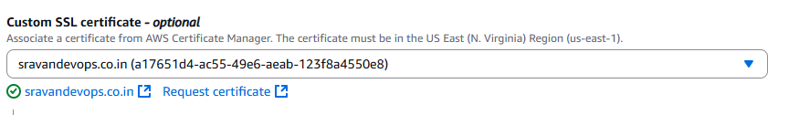

4.Create a Route 53 hosted zone and map the domain with the CDN.

## **Step 1 — Create Route 53 Hosted Zone**

1. Go to **AWS Route 53 Console** → **Hosted Zones** → **Create hosted zone**.
2. Enter:
   * **Domain name**: sravandevops.co.in
   * **Type**: Public hosted zone
3. Click **Create hosted zone**.

You will now see your new hosted zone with **NS (Name Server) records**.

## **Step 2 — Update Domain Registrar**

Your domain registrar (where you bought sravandevops.co.in) must point to Route 53 name servers.

* Copy all **NS record values** from your Route 53 hosted zone.
* Go to your registrar’s DNS settings and replace the current name servers with Route 53’s name servers.
* This step is crucial so Route 53 controls your DNS.

## **Step 3 — Create CloudFront Distribution**

(If not done already)

1. Go to **CloudFront console** → **Create distribution → Web**.
2. Set **Origin Domain**: your S3 bucket endpoint (e.g., sravandevops.co.in.s3.amazonaws.com).
3. Alternate Domain Names (CNAMEs):
4. sravandevops.co.in
5. www.sravandevops.co.in
6. SSL Certificate: Choose your ACM certificate for sravandevops.co.in.
7. Viewer Protocol Policy → **Redirect HTTP to HTTPS**.
8. Click **Create Distribution**.  
   Wait ~10–15 minutes for deployment.

## **Step 4 — Map Domain to CDN**

Once CloudFront distribution is deployed:

1. Go to Route 53 hosted zone for sravandevops.co.in.
2. Click **Create record** → **Simple record**.
3. Select:
   * **Record name**: leave empty for root domain (sravandevops.co.in)
   * **Record type**: A — IPv4 address
   * **Alias**: Yes
   * **Alias target**: Select your CloudFront distribution.
4. Click **Create records**.

(Optional) If you want www.sravandevops.co.in:

* Create another record:
  + **Record name**: www
  + Alias to same CloudFront distribution.

## **Step 5 — Test**

After DNS propagation (~minutes to hours):

https://sravandevops.co.in

should serve your S3 static site via CloudFront with HTTPS.

